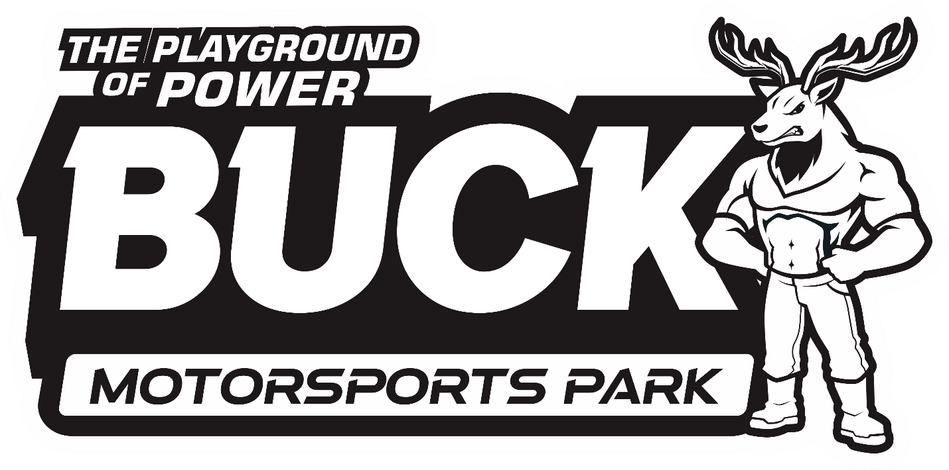

2025
Semi-Truck
Buck Motorsports Park
900 Lancaster Pike, Quarryville, PA 17566
Competitor@BuckMotorsports.com
Track Phone: (717) 284-2139 www.buckmotorsports.com
Facebook Competitors Group
Buck Motorsports Park – Competitors

2024 Semi-Truck Schedule
July 19 | Limited Pro Stock Semis
August 16th | Strictly Street Pulling & Drag Racing Renegade Street & Pro-Stock Pulling
September 12th | Limited Pro Stock Semis

- Competition Class Structure - (SS) Strictly Street Semi Truck
Sled Pulling / Drag Racing

(RS) Renegade Street Semi Truck
Sled Pulling

(PS) Limited Pro Stock Semi Truck
Sled Pulling – PPL RULES

Semi-Truck Purse Structure

-Sled Pulling-
(SS) Strictly Street: Entry Fee $20
Payout Schedule
1st | $200 + Trophy
2nd | $150 + Trophy
3rd | $100
4th | $50

(RS) Renegade Street: Entry Fee $20
Payout Schedule
1st | $300 + Trophy
2nd | $200 + Trophy
3rd | $100
4th | $50

Limited Pro Stock : Entry Fee $20
Payout Schedule
1st | $1000 + Trophy
2nd | $500 + Trophy
3rd | $350
4th | $150
5th | $150
6th | $100
7th | $100
8th | $100

-Drag Racing-
(SS) Strictly Street Only: Entry Fee $20
Payout Schedule
1st | $200 + Trophy
2nd | $150 + Trophy
3rd | $100
4th | $50

OPERATION OF CONTEST RULES

- All contestants at every event must sign a release and entry form, understanding that they are competing at their own risk and that they will not bring suit against any officials, employees, Promoter, and/or property owner. By signing the release and entry forms you agree to all rules set forth and warrant that your vehicle meets all the requirements for this class.
- A contestant may be disqualified for either emotional or physical reasons by Competition Director or track officials. Example: Disrespecting Buck Motorsports Park Staff, causing an aggressive scene, recklessness, drugs or drinking alcoholic beverages. Any driver or any of his or her pit crew consuming an intoxicating agent, and/or drugs, prior to or during the event will be disqualified from the event. Drivers will be held responsible for the actions of their crew!
- Tech officials reserve the right to revise and alter rules throughout the season.
- All participants must possess a valid state issued identification card. All competitors ages 16 and 17 years old. MUST hold a Valid State Driver’s License in order to compete. As well as have a parent or legal guardian signed competition release form.
- All vehicles must register and pass tech inspection before competing. Registration and tech inspection area will open at 3:00 pm and close at 5:30 pm.
- Entry fee amount for Sled Pulling - $20.00
Entry fee amount for Drag Racing - $20.00

A vehicle can enter one pulling class per event and one drag racing entry per event. No switching drivers for multiple entries. Driver can only enter 1 time per Class, all points go to driver, not the truck! Pit gates will open at 3:00, registration and tech will close at 5:30 pm.
- All drivers must attend driver’s meeting approximately 1 hour before event starts.
- A vehicle cannot be registered after driver’s meeting unless approved by track official.
- Only the driver will be allowed in a vehicle during competition. (No Passengers)
- No one allowed on the track except for track officials and contestant. Track is defined as the area with in 35' in any direction of the contest boundaries, including the runoff area at the finish end of the track.
- All contestants must drive vehicle onto track and into position to compete under its own power and must leave track under its own power unless for breakage. Vehicle must be in neutral or park while hooking to or unhooking from sled. Driver should
raise hands while hooking or unhooking from sled.
- All pulls must start with a tight chain; no jerking of any kind is permitted. Vehicle must remain within boundaries of the track, or the puller will be disqualified.
- Puller will be allowed a total of two attempts to reach the 75' mark. If puller goes past 75' mark on 1st attempt, no re-hook allowed. Test puller may drop 6 positions or rehook immediately. Test puller may drop to last only for mechanical breakage (visible to track official)
- Driver must wait for green flag from starting line flagman before starting the pull. Leaving the starting line while under the red flag, will be an automatic disqualification. No exceptions.
- Vehicle must stop immediately upon signal of red flag from flagman.
- Competition vehicles must be always operated in a safe manner within the confines of the track, pit area, and staging areas. Track officials have the right to stop and disqualify any vehicle being operated in a reckless manner. Pit and staging areas speed limit is 5 M.P.H.
- A contestant may be disqualified for either emotional or physical reasons by Competition Director or track officials. Example: recklessness, drugs or drinking alcoholic beverages. Any driver or any of his or her pit crew consuming an intoxicating agent, and/or drugs, prior to or during the event will be disqualified from the event. Drivers will be held responsible for the actions of their crew!
- If any vehicle and/or driver is disqualified for any reason, no refund of entry fee or pit fee.
- All vehicles must be equipped with a 2-1/2 lb. dry chemical fire extinguisher or 1 lb.
halon extinguisher. Extinguishers must be fully charged, in working condition, and secured convenient to driver.
- Seat belts with shoulder strap are required and must be worn during competition.
- Driver must wear D.O.T. approved helmet. Helmet strap must be fastened. Driver must also wear long sleeve shirt and long pants, unless otherwise stated.
- All vehicles must have a 4-wheel hydraulic brake system in good working condition, unless otherwise noted.
- D.O.T. Tires only. No Cutting or studding allowed.
- All engine fans must be shrouded.
- Fuel must be #1/#2 diesel fuel only. Soy/biodiesel fuel is permitted. No other combustible material (nitrous, propane, etc.) may be injected into the turbocharger or any part of the air intake system. Water injection is not permitted. All nitrous, propane and water injection systems must be removed from vehicle.
- In a pull-off, each competitor will hook in the order pulled in original class lineup. Each competitor will have 2 attempts to make a measurable pull. No dropping of positions is allowed in a pull-off.
- In a pull-off, if the track official determines an error has occurred in the sled setting, pull-off may be restarted. First puller may come right back or drop to last.
- Track officials will have the option to cheek competitors for rule violations at any
time during the events. Contest will be governed by Track Officials and Competition Director with all decisions final!
- The Promoter or Competition Director reserves the right to change any safety rule or rules if they feel it is necessary.
- Verbal or physical abuse toward any track official will result in automatic disqualification.
- Most Importantly Be Safe and Have Fun!
- Protest Procedure - any participant wishing to protest another participant will be allowed to do so under the following guidelines: Drivers must be registered for the event. A formal protest must be file with the Competition Director, form must be complete, and must be submitted prior to the start of competition. A $200 cash protest fee will be required. The vehicle protested will be accompanied and evaluated by Buck Motorsports Officials and the driver of the protested vehicle. If vehicle is found to be non-compliant with Buck Motorsports Rules, the driver will need make the vehicle compliant or be eliminated from competition that day. If vehicle is non-compliant the funds will be refunded to the driver who initiated the protest. If the vehicle is found to be compliant, the funds will be split evenly amongst the protested driver and the 1st place purse amount.

The rules and/or regulations set forth herein are designed to provide for the orderly conduct of the competition events and to establish minimum acceptable requirements for such events. These rules shall govern the condition of all events, and by participating in these events, all participants are deemed to have complied with these rules. NO EXPRESSED OR IMPLIED WARRENTY
OF SAFTEY SHALL RESULT FROM PUBLICATIONS OF OR COMPLIANCE WITH
THESE RULES AND OR REGULATIONS. They are intended as a guide for the conduct of the sport and are in no way a guarantee against injury or death to a participant, spectator, or official.
The event director shall be empowered to permit minor deviation from any of the specifications herein or impose any further restrictions that in his opinion do not alter the minimum acceptable
requirements. NO EXPRESSED OR IMPLIED WARRENTY OF SAFETY SHALL RESULT FROM SUCH ALTERATION OF SPECIFICATIONS. Any interpretation or deviation of these
rules is left to the discretion of the officials. Their decision is final! For tech questions email us at competitor@buckmotorsports.com or call the office.

OPERATION OF DRAG RACING CONTEST RULES

General Competition Rules
- When competition is side by side, any competitor that leaves before light is green is automatically disqualified. Official has final say.
- In the event of disqualification, the other competitor immediately automatically advances, and the race is deemed complete.
- In the event of an uneven number of competitors a random bye run is chosen.
- Competitors and vehicle can only run one class per night.
- All competitors must be 18 years old and possess a valid driver’s license from their state

Round 1 Rules
- If you are unable to pull to the line and stage once your competitor has staged, you have forfeited your round.

Round 2 - Semi Final Rules
- If a competitor cannot race the loser of the previous round will advance and take their spot. If the loser cannot make run, then the other competitor will get a bye run.

Final Round Rules
- If a competitor cannot make the final round, the loser of the previous round will advance and take the spot. If the loser cannot make the final round, then the opposing racer will re-race as the final round. If the opposing racer cannot make it then race is called.

- Buck Motorsports Park -
(SS) Strictly Street Semi-Truck
Sled Pulling / Drag Racing Rules

Weight of truck and driver 20,000 LBS. MAX.

- No added weight or ballast permitted. Trucks shall appear “road ready”. Trucks such as oil field trucks that
carry additional weight that is not normally found on a “road ready” truck are not permitted in this class.

- Trucks are expected to be capable of being driven on the highway regularly and must be capable of pulling a trailer.

- Triple rear axles are not permitted.

- Promoter will supply a hitch for use by any owner that does not have their own. Hitch must work from the 5th wheel with the 5th wheel between the two rear axles. The hitch must be adjusted to a height determined by track crew.

- Use of suspension air bags is permitted, however no air may be added or removed while the truck is hooked to the sled. Hitch must remain the same height from start to finish.

- Chaining or blocking of drive axles is not permitted.

- Single turbo only except for factory installed twin turbo chargers.

- No ether, alcohol, nitrous or other combustible liquid or material may be injected into the turbo charger or any part of the air intake system.

- Pump diesel fuel is the only fuel permitted in this class.

- Maximum engine RPM allowed will be 2300 RPM, verified on the vehicle tachometer or photo tachometer at tech. inspection.

- Buck Motorsports Park -
(RS) Renegade Street Semi-Truck
Sled Pulling Rules

Weight of truck and driver 20,000 LBS. MAX.

- No added weight or ballast permitted. Trucks shall appear “road ready”. Trucks such as oil field trucks that
carry additional weight that is not normally found on a “road ready” truck are not permitted in this class.

- Trucks are expected to be capable of being driven on the highway regularly and must be capable of pulling a trailer.

- Triple rear axles are not permitted.

- Promoter will supply a hitch for use by any owner that does not have their own. Hitch must work from the 5th wheel with the 5th wheel between the two rear axles. The hitch must be adjusted to a height determined by track crew.

- Use of suspension air bags is permitted, however no air may be added or removed while the truck is hooked to the sled. Hitch must remain the same height from start to finish.

- Chaining or blocking of drive axles is not permitted.

- Single turbo only except for factory installed twin turbo chargers.

- No ether, alcohol, nitrous or other combustible liquid or material may be injected into the turbo charger or any part of the air intake system.

- Pump diesel fuel is the only fuel permitted in this class.

- Maximum engine RPM allowed will be 3000 RPM, verified on the vehicle tachometer or photo tachometer at tech. inspection.

